**NON-DISCLOSURE AGREEMENT**

This Non-Disclosure Agreement ("Agreement") is made as of 14/02/2024, by and between the following parties:

* **Students:**

**Alosh Denny, Augustine Anish**, **Tanu Shree**, and **Jayalakshmi PE**, all currently enrolled in the S6 semester of Computer Science (CS) and Information Technology (IT) at **School of Engineering, Cochin University of Science and Technology, Ernakulam**, herein referred to as the "Recipient(s)";

* **KSCSTE - National Transportation Planning and Research Centre ("KSCSTE - NATPAC"), Ernakulam**, herein referred to as the "Disclosing Party".

The Recipient(s) and the Disclosing Party may collectively be referred to as the "Parties".

WHEREAS the Disclosing Party agrees to disclose certain confidential information related to "visualizing and forecasting import and export traffic demand of Cochin Port and its hinterlands" for the purpose of enabling the Recipient(s) to work as **data science interns**;

AND WHEREAS, the Recipient(s) agrees to receive such confidential information under the terms and conditions of this Agreement;

NOW, THEREFORE, in consideration of the mutual covenants and agreements contained herein, the Parties agree as follows:

1. **Definition of Confidential Information:** Confidential Information includes all data, materials, products, technology, computer programs, specifications, manuals, business plans, software, marketing plans, financial information, and other information disclosed or submitted, orally, in writing, or by any other media, to Recipient(s) by the Disclosing Party. Confidential Information does not include information that:
   * 1. is known to Recipient(s) at the time of disclosure as evidenced by written records of the Recipient(s);
     2. has become publicly known and made generally available through no wrongful act of the Recipient(s);
     3. is rightfully received by Recipient(s) from a third party without breach of this Agreement.
2. **Non-Disclosure of Confidential Information:** The Recipient(s) agrees not to use the Confidential Information for any purpose except for the specified purpose of this internship or disclose any of the Confidential Information to any person or entity other than as necessary to fulfill the purpose of this internship.
3. **Maintenance of Confidentiality:** The Recipient(s) agrees to take all reasonable steps to ensure that Confidential Information is not disclosed or distributed by its employees or agents in violation of the terms of this Agreement.
4. **Return of Confidential Information:** Upon the conclusion of this internship, or upon the request of the Disclosing Party, the Recipient(s) shall return all copies of Confidential Information received from the Disclosing Party or certify in writing that all such material has been destroyed.
5. **No License:** Nothing in this Agreement is intended to grant any rights to the Recipient(s) under any patent, trademark, copyright, or other intellectual property rights of the Disclosing Party. The Recipient(s) expressly agree that the Confidential Information is provided on an "as-is" basis.
6. **Term:** The obligations of this Agreement shall be in effect from the date of this Agreement until the Confidential Information no longer qualifies as a trade secret or until the Disclosing Party sends the Recipient(s) written notice releasing them from this Agreement, whichever occurs first.
7. **Governing Law:** This Agreement shall be governed by and construed in accordance with the laws of [Jurisdiction].
8. **Entire Agreement:** This Agreement constitutes the entire agreement between the parties with respect to the subject matter hereof and supersedes all prior or contemporaneous agreements, whether written or oral.

IN WITNESS WHEREOF, the Parties have executed this Agreement as of the date first above written.

**For KSCSTE - National Transportation Planning and Research Centre:**

Name: Dr. Rameesha

Title: Junior Scientist

Date: 14/02/2024

<signature>

**For the Recipient(s):**

Name: Alosh Denny

Date: 14/02/2024



Name: Augustine Anish

Date: 14/02/2024

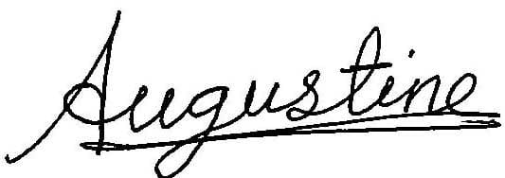

Name: Tanu Shree

Date: 14/02/2024

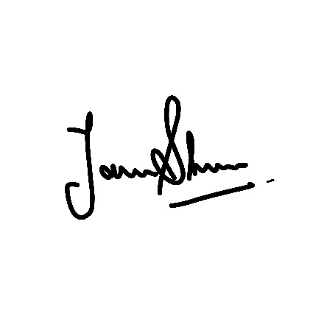

Name: Jayalakshmi PE

Date: 14/02/2024

